The New Chief – A Play by Salinan Nation Chief, Whitewisp October 2002

Performed at Jones Gulch, October 2002 By Chief Whitewisp, Princess Snowcloud and the Princesses of the Hupa Tribe

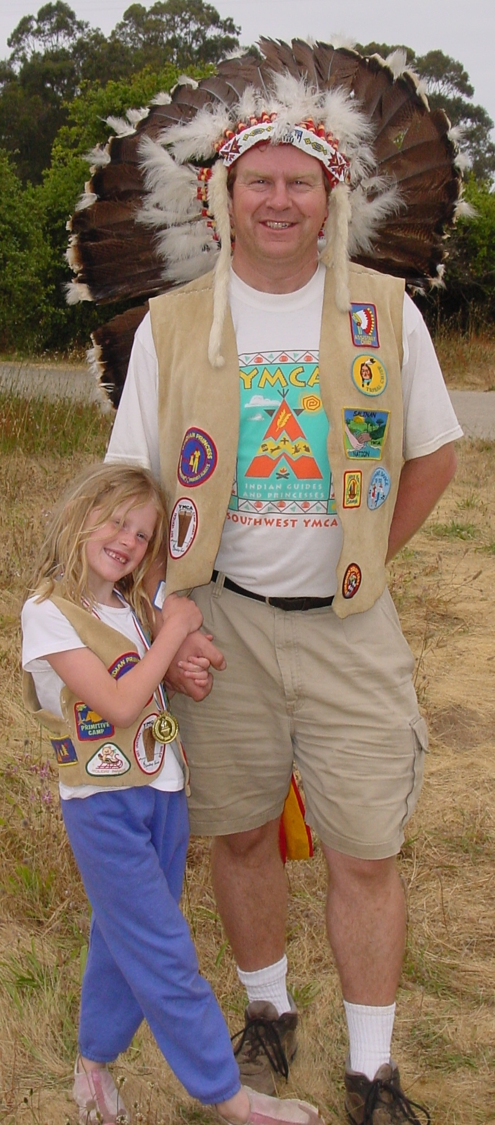
STORYTELLER: This is an important day for the Salinan Nation. Our first CHIEF and founder Gathering Storm was originally from the Cherokee Nation. Our second CHIEF, last year’s CHIEF, Shooting Star was also from the Cherokee Nation. I have only known the Salinan Nation and I must ask myself what does it mean to be CHIEF and how can I do it well.
I have looked for inspiration to the story of a man who lived many, many years ago. He was a real CHIEF, a great CHIEF of a real Indian Nation and lived here in Jones Gulch area.

STORYTELLER It was all so long, long ago that we don’t even know his name, but we know he was from the group of nations that the Spanish settlers here called Coastanoan.
This man did not expect to become CHIEF. His father was the CHIEF and his grandfather had been CHIEF. But he had an elder brother who would become CHIEF instead.
One day he heard terrible news. It had been a very long hot dry summer and the braves were out hunting when a lightening storm caused a great wildfire. The CHIEF’s father and brother had been killed in the fire while trying to save some of the braves.
The young man was very sad when he heard the news and very scared when he realized that he was now the new CHIEF. He realized that he had a big responsibility.
The people needed him to lead them, to organize the nation, to prepare for winter.
He looked up into the smoke of the campfire and imagined he could see the faces of the great leaders of the past.

<<<Images are Projected into the smoke>>>
<<<Hupa tribe members sneak out and crouch around the fire>>>

CHIEF:See how wise and powerful they look. Can I ever be as great a CHIEF as these CHIEFs from long ago?

STORYTELLER It would be difficult but he knew he had to try. It was his responsibility.

CHIEF: I can do this. I will be a great leader of my people.
CHIEF: Where is my daughter SNOWCLOUD?

SNOWCLOUD: Here I am father

CHIEF: It is the end of Summer and it will soon be Winter. Now that I am CHIEF you must lead the ACORN GATHERERS so that we shall have bread this winter.

SNOWCLOUD: Don’t worry father, Grandmother has taught me well. Come ACORN GATHERERS, bring your baskets and follow me to the oak trees.

<<<<SNOWCLOUD and the ACORN GATHERERS leave for the oak trees.>>>>>

STORYTELLER The CHIEF thought “well, that was pretty easy. I just tell them to go do stuff and off they go!
Oh Oh, here they are back already!!”

SNOWCLOUD: Father, we went to the oak trees and we could hardly find any acorns this year.

CHIEF: Then you didn’t look hard enough. Go again and look harder!

SNOWCLOUD: but father……..

CHIEF: GO!!
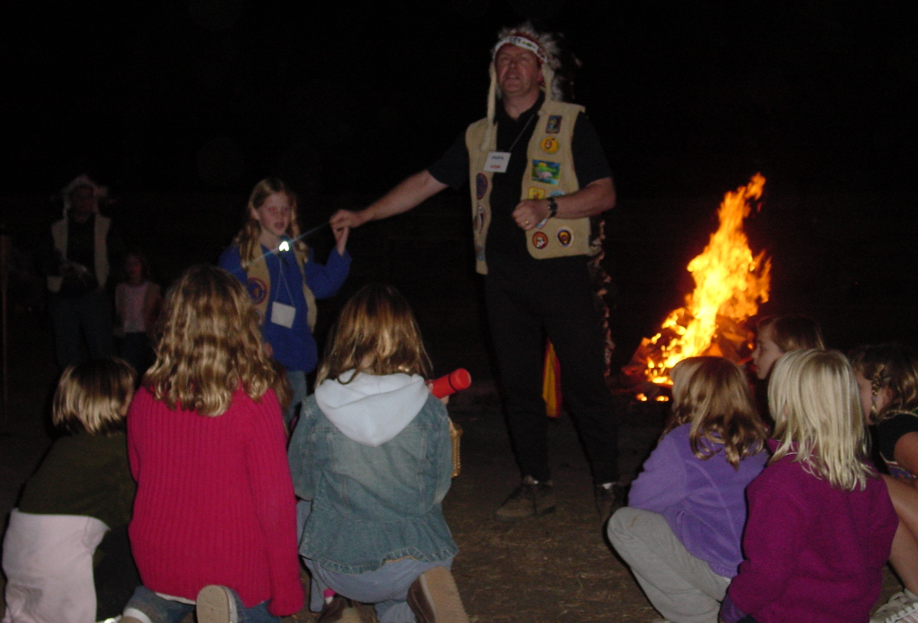

CHIEF’S MOTHER : My Son

CHIEF: Mother – you shouldn’t call me at work.

CHIEF’S MOTHER: Do you remember how dry it was this year?

CHIEF: Yes, There was almost no rain at all this year. The deer came to our village looking for food.

CHIEF’S MOTHER: When your grandfather was CHIEF and I was the leader of the ACORN GATHERERS there was a year like this when almost no rain fell. We went to the oak trees and there were no acorns.

CHIEF: There were no acorns that year?? Then what did you do?

CHIEF’S MOTHER: Your grandfather sent us to the Dark Canyon, there we found many acorns.

CHIEF: But were you not afraid????

CHIEF’S MOTHER : Your grandfather sent some braves with us.

<<<<<The ACORN GATHERERS return>>>>>

SNOWCLOUD: Father we have returned but there were no acorns to be found.

CHIEF: SNOWCLOUD, you must take the ACORN GATHERERS to the Dark Canyon where you will find cool shade and many acorns

ACORN GATHERERS - The Dark Canyon!!!???

CHIEF: These BRAVES will go with you and protect you

STORYTELLER And so the BRAVES and ACORN GATHERERS went into the Dark Canyon. Well now the CHIEF felt very worried. He had sent almost all the tribe into the Dark Canyon where almost nobody went. Who knows what dangers might be there? What if they never came back, what if………

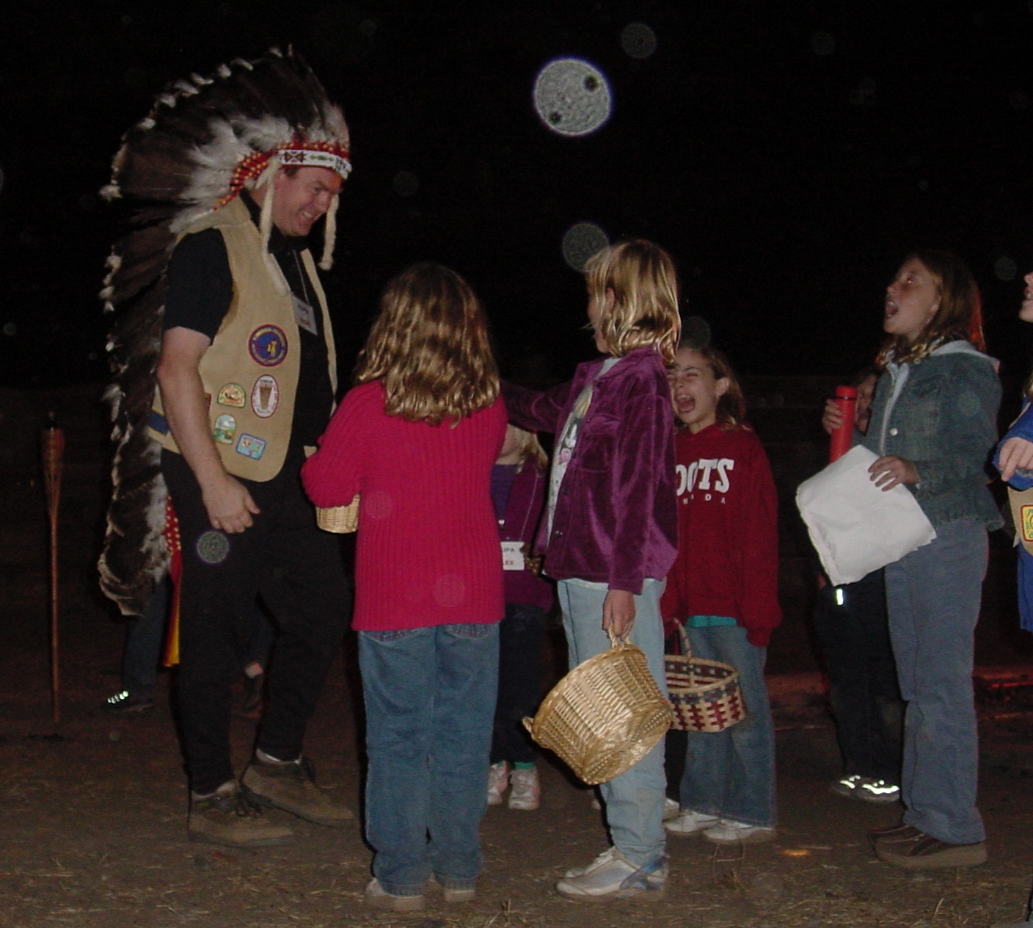
BIG BRAVE – Helloooooo!!!!!

CHIEF : Who calls??

BIG BRAVE: It is us

SNOWCLOUD : Father we found lots of acorns

BIG BRAVE : And we caught meat to eat. The Dark Canyon was a great idea

CHIEF : Well, eh,…..

CHIEF’S MOTHER : Great idea oh CHIEF.

CHIEF : OK, well eh. ACORN GATHERERS you need to put the acorns over here and, eh, well you need to…………….

SNOWCLOUD “Father, we are the ACORN GATHERERS, we know what to do”

STORYTELLER And so they did. They emptied the acorns from the baskets into stone basins and pounded the acorns into powder.

CHIEF –Tries the powder and spits it out. “Oh that tastes bad!!”

SNOWCLOUD – Father you cannot eat the acorns until we have washed out the bad taste

STORYTELLER – and the ACORN GATHERERS poured the powder into holes in the ground

STORYTELLER – and then the ACORN GATHERERS made hot water by gathering water from the stream in woven baskets made so skillfully that they held the water without leaking.
To make hot water the acorn gathers brought a hot stone from the fire and dropped it into the basket of water. When they dropped the hot rock from the fire into the basket of water it made a sound like this:

ACORN GATHERERS – SSSSSSSSSSSS

STORYTELLER –and the ACORN GATHERERS poured the hot water from the basket onto the acorn powder and let it drain away, then they got more water and another hot rock and again it made a sound like this:

ACORN GATHERERS – SSSSSSSSSSSS

STORYTELLER –And finally the squishy dough was dried by the fire and turned into a delicious bread. The BRAVES had cooked the meat.

ACORN GATHERERS AND BRAVES – Here is dinner Oh CHIEF
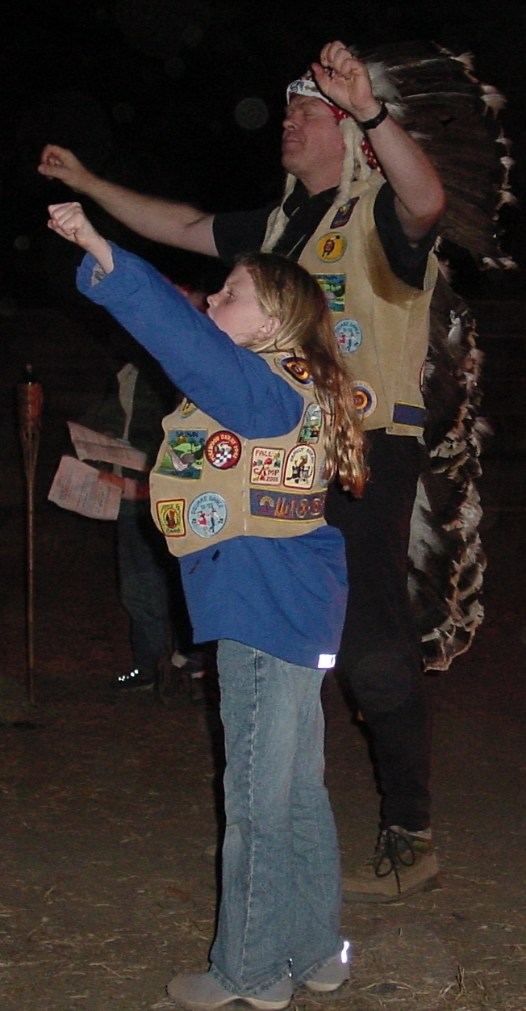
<<<They leave bread and meat near the CHIEF and start to move away>>>

CHIEF Hey, where is everyone going. Let us feast together.
We shall celebrate a great day together!!!!

<<All stand together and shout:>>>

EVERYONE: “ NOONWAY!!! NOONWAY NOONWAY!!!!”

<<<<<Hupas return to their seats>>>>>

STORYTELLER And so I have learned from the story of CHIEF
Respect the advice of elders.
Don’t advise people when they already know what they are doing.
Bring the Nation together at gatherings such as this.

EVERYONE: “ NOONWAY!!! NOONWAY NOONWAY!!!!”

