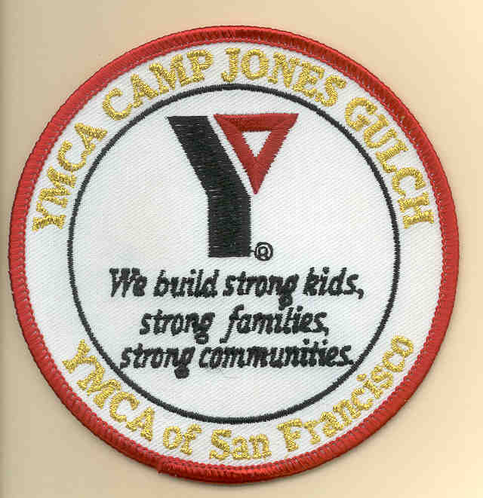

Connected
Story told by Salinan Nation Chief
Gathering Storm
at the Fall Cabin Campout
on 21 October 2000

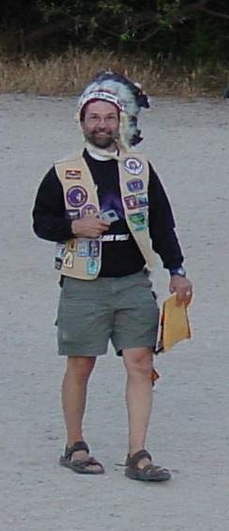
This story has been 6 years in the making.
It’s been on my mind ever since our Assistant Nation Chief
Told me about his idea for the Story Stick.

I put pen to paper, and then finger to keyboard
While waiting for a plane last night in Atlanta.
The original homeland of the real Cherokee Nation
includes at least part of Georgia.
Since some tribes in our nation came out of the Cherokee Nation, That was an unexpected connection.
I distinctly remember being in this very place 6 years ago
It was my first nation event ever.
It was the first event for the Shoshone Tribe.

My older daughter and I were newcomers
Many of you are also newcomers
And to each of you new folks I feel connected.

To those of you who have been to campouts before
I hope the experience tonight in our new nation will feel different and exciting.

This fall campout event cements your relationship with this program.
I hope you all feel connected with it here tonight.

There are so many kinds of connections:
Between your tribe and our nation
Between you and your tribe
Between you and the forest, field and stream that surround us tonight
Between you and the stars overhead

But tonight most importantly,
I hope you feel connected as daughter and father.
Because it is this connection that brings us together tonight.

Because this is so important
I want to share with you something that you will always have
To instantly remind you of this connection

It’s our Secret Handshake.
I’ll bet you didn’t know this nation had a secret handshake!

